**Data visualization with Power BI using FHIR analytics pipelines for Breast Cancer Screening (BCS)**

With Power BI as Data visualization tool, this is an application to visualize FHIR Data using FHIR Analytics Pipeline. In pipeline new or updated FHIR data is moved to Azure Data Lake stores data in parquet files, from parquet files we create external tables and views in Azure Synapse Analytics database with Serverless SQL pool. On the Database we have stored procedures to calculate data as per quality measures, that stratified data is visualized on power BI desktop report.

**About FHIR to Data Lake pipeline:**

The FHIR Analytics Pipeline is an Azure Function that continually exports new and modified FHIR resources in specific time chunks to Azure Data Lake Storage in the form of Parquet files. By default, this function runs every 5 minutes and exports changed data in five-minute chunks (or windows). Each export window will only export the latest version of a resource and a single resource will exist in multiple windows as it's changed in the FHIR service.

Figure 1 - Sample Data Flow for FHIR analytics pipeline and Power BI sample application

**Database in Synapse:**

A database is created in Synapse with serverless pool, database has External Tables and Views pointing to the parquet files in the Azure Data Lake Storage.

**About Power BI Dashboard:**

The Power BI dashboard demonstrated in this document uses the sample quality measure below to get the data from Serverless SQL tables/views using stored procedures to show data visualization in power BI.

**Quality Measure**:

Percentage of women 50-70 years of age who had a mammogram to screen for breast cancer in the 48 months prior to the end of the measurement period.

Note: This sample is not the same as the HEDIS eCQI digital quality measure. This is a basic sample to demonstrate capabilities of FHIR analytics Pipeline and Data Visualization with Power BI. This sample uses Synthea data comprising of SNOMED codes

Below is the prerequisite that we need for this application:

1. Microsoft work or school account
2. Azure Synapse Workspace with Serverless SQL Endpoint.

* The Serverless SQL Endpoint will be used to connect to Database from Power BI Desktop Application to create Power BI Dashboard/reports.

1. Power BI Desktop application

* It is available for download [here](https://www.microsoft.com/en-us/download/details.aspx?id=58494).

1. Power BI service account

* Login to power BI service [here](https://msit.powerbi.com/home) and create a workspace where Power Bi reports will be published from Power Bi Desktop App

1. Microsoft SQL Server Management Studio

* It is available for Download [here](https://learn.microsoft.com/en-us/sql/ssms/download-sql-server-management-studio-ssms?view=sql-server-ver16).

## **Connecting to Database from SQL Server Management Studio**

To explore (view/edit) the stored procedures definition for any stored procedure used for Power BI dashboard report, connect to database from synapse using serverless SQL pool endpoint, Serverless SQL endpoint could be found in Synapse Workspace as highlighted below:

1. Open the “Microsoft SQL Server Management Studio”, from “Object Explorer” menu click on “Connect” and select “Database Engine” from list.

1. Enter serverless SQL endpoint from Synapse workspace into server name textbox, choose authentication method, provide username ad click connect:

1. After clicking connect you will be asked to provide authentication details for user, once user authentication is done, database connection will be done:

1. Once the connection is made you would be able to see “fhirdb” database, stored procedures should be available inside “Programmability => Stored Procedures” folder as shown below:

## **Checking and editing the dashboard in Power BI desktop application**

Before proceeding ahead with dashboard, please connect to “fhirdb” database using serverless SQL endpoint from Microsoft SQL Server Management Studio and make sure the stored procedures are created there.

1. Save the provided report file (.pbix file) to your computer.

1. Double click on report file(.pbix) to open it in Power BI Desktop application, the report file has multiple pages, “Main Dashboard” is the landing page, as shown in below image:

The report has below pages:

1. Main Dashboard

* It’s an entry point for a report, it shows all the graphs at one place with navigation buttons to detailed pages.

1. Data By Age

* This page shows graph with Age range and age wise

1. State wise Percentage

* This page shows the map with state wise percentage of Numerator population

1. Data By Race Category

* This page shows graph with count of Numerator population with each Race Category

1. Data By Ethnicity Category

* This page shows graph with count of Numerator population with each Ethnicity Category

1. Payor Details

* This page shows graph with percentage of Numerator population with payors

1. Tabular Data

* This page shows table of data for Numerator population

The Main Dashboard page in report shows all the visualizations listed below:

* Age range chart
* State wise Percentage
* Count by Race Category
* Count by Ethnicity Category
* Payor wise percentage
* Button to navigate to tabular data

Age Range, Race Category and Ethnicity charts get data from “NumeratorDetails” table.

State wise Percentages chart gets data from “StatewisePercentage” table.

Payor wise Percentage chart gets data from “PayorwisePercetage” table.

1. Below image shows the “Data” section of the report which has tables, on selecting specific table in the right-hand side pane, it will show the data in that table as shown in below image:

1. The “Model” section shows all the table and the relationships (if any) as shown in below image:

## **Editing the query to change measurement period date range in parameters**

1. Go to “Model” section, here one can see the table is available, and can view properties and fields of the table, when you click “More Options” button (Three dots in top right corner of the table Shape, rectangle

   Description automatically generated), it shows all the options available for the table, click on “Edit Query”

1. A new “Power Query Editor” window will open, click on expand arrow button as highlighted in below image which will show the query:

1. If this is first time you are editing query in .pbix file, you will have to change the serverless SQL pool URL (blacked out part) in below image, you will be asked to edit credentials to connect to your SQL serverless pool URL, you will see “Edit Credentials” button, click on it and login using Microsoft account as shown in step 8, If query already has your SQL serverless URL then no need to change it, just change parameter values as shown in below step.
2. Change the date value in query for measurement period start date and end date, first value is for start date and second value is for end date parameter respectively, so we have set 11/14/2010 as measurement period start date and 11/17/2022 as measurement period end date:

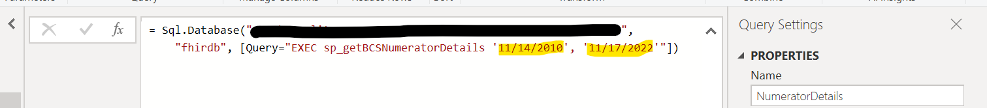

After editing the values, click on right tick as highlighted in image below:

1. If there is an “Edit permission” button, click on it, If there is “Edit Credentials” button, jump to step 7.

1. On new pop-up window click on “Run” button:

1. Query will be executed, latest result data will be loaded into the table, this will complete query editing, close the “Power Query Editor” window:

1. If you see “Edit Credentials” button as shown below, click on it

1. A New popup window will appear, select Microsoft account from left-hand side pane and click sign in, sign in with Microsoft account and click on connect.

1. In a similar manner date parameters can be changed for “StatewisePercentage” and “PayorwisePercentage” tables.

## **Publish the dashboard in Power BI Service**

To be able to view the dashboard in Power BI service we need to publish it from Power BI desktop application to Power BI Service.

1. If any changes are made to dashboard, save the changes, and then click on “Publish” option from “Home” menu as shown in image below:

1. It will ask for the workspace in power BI service where you want to publish it, Select the specific workspace from dropdown list and click “Select”, in our case workspace name is “Quality Measure”, as shown in below:

1. If it is a fresh report, it will get published. In case you already have the report in workspace with same name, it will ask for confirmation to replace existing one. If you wish to replace the existing one click on replace, otherwise click cancel and save file with different name and follow steps again.

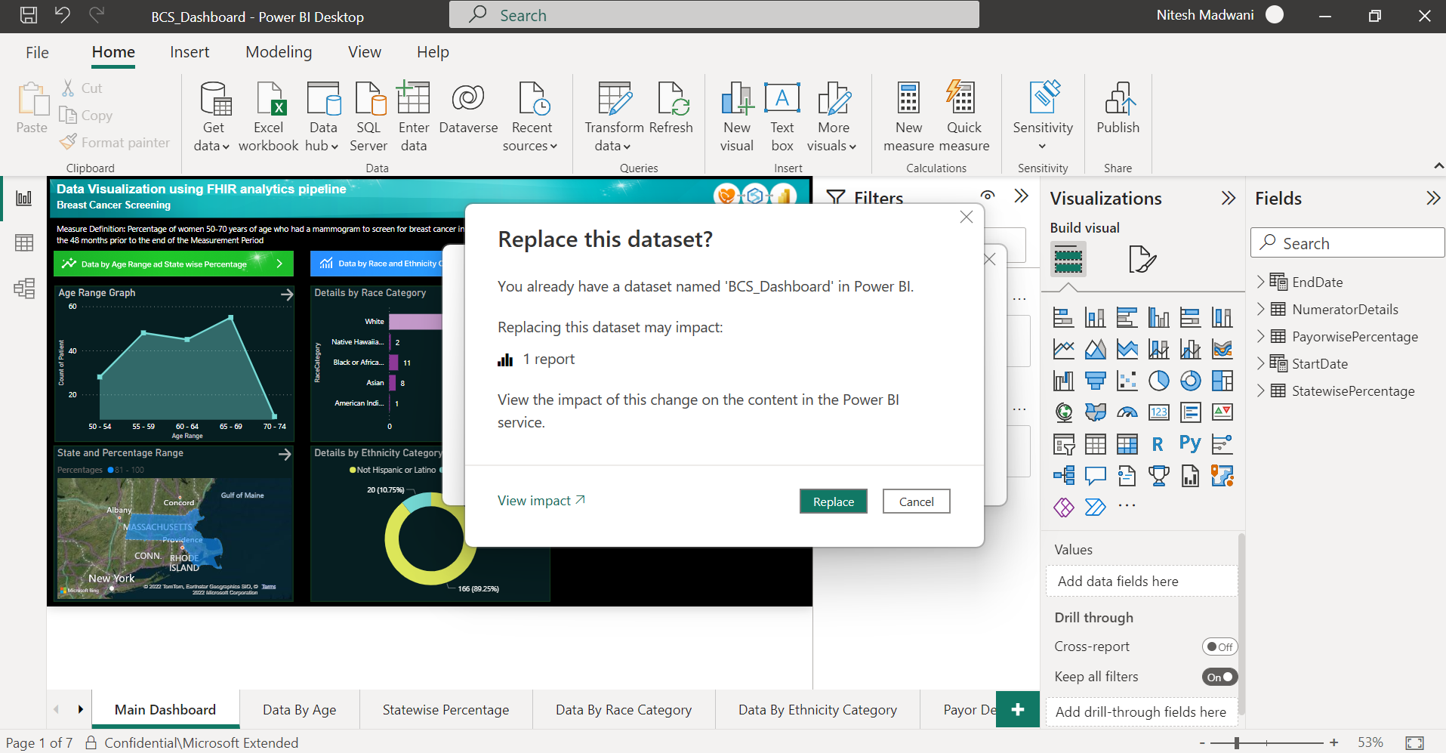

1. Once the report is published successfully, it will show pop-up with success message, click on “Got it” as below

## **View the dashboard in Power BI service**

1. Login to Power BI service and select your workspace in left-hand side pane, under workspaces scroll down and select your report from “Reports” section, once you select the report, it will open, and you can see all the pages listed in “Pages” as highlighted in below image:

1. The arrow sign button at top right corner of each graph in main dashboard will navigate to detailed page as shown below:

1. Each detailed page has a navigation button which navigates back to Main Dashboard page as shown below:

